

**The Pitfall of Telework – The Relationship between Telework and Self-reported Task Performance Mediated by Cyberslacking, and the Role of Goal setting.**

Bianca Maria Del Re, 13883135

May 31st, 2023

University of Amsterdam, Department of Psychology

MSc Psychology (Track: Consultancy and Organizational Development)

Supervisor: Dr. Marije de Goede

Second Assessor: Dr. Jiafang Chen

**Abstract**

This study aimed to investigate the relationship between teleworking, cyberslacking, and self-reported task performance, and to explore the potential pitfalls of remote working. According to the research, the relationship between telework and task performance is mediated by increased cyberslacking, leading to lower performance among teleworkers. Additionally, the study introduced goal setting as a moderator, indicating that people who set work goals would engage in less cyberslacking. This topic was investigated with a cross-sectional study design that involved sending an online questionnaire to 235 participants. The results indicated that intensity of telework is not related to self-reported task performance through cyberslacking when people make use of goal setting. However significant relationships have been found between goal setting and task performance, as well as the interaction of goal setting and telework on cyberslacking. This means that people who set goals tend to show a better overall task performance. Moreover, it indicates that people who do not set goals tended to cyberslack more when working remotely. The findings of this thesis are relevant for future research as they indicated that goal setting might be a good strategy for employees to stay focused and increase their performance. However, the results regarding telework and cyberslacking indicate that there might be other factors and distractors placing a role in this relationship. Therefore, future research needs to have a more nuanced approach to these concepts in order to get a clearer picture of the benefits and drawbacks of telework.

*Keywords: Telework, Cyberslacking, Task Performance, Goal Setting*

**Introduction**

Nowadays, if you ask someone about the benefits of working remotely, they will most likely tell you about how much more productive they can be at home, because they get less distracted. But how many times during their work do people pick up their phone to read a private message they received, or to check the score of a football game? Recent research shows that people spend up to 7 hours a day, which is over 40% of their waking hours on an internet-connected screen (Howarth, 2023), and for sure not all of it is for work-related purposes. Worst of all, most people are not even aware of how much time they spend online, especially during work. So, the question is, are people actually less distracted and therefore more productive in their work? Or do they experience different kinds of distractions when working remotely?

There is a lot of prior research on remote working. One form of remote work that is very commonly researched is telework, which is defined as the practice of working from home and making use of the internet, email, and the telephone (Greer & Payne, 2014). It has been linked to several positive outcomes like increased work-life-balance (Gajendran & Harrison, 2007) or higher job and life satisfaction (Fonner & Roloff, 2010; Tremblay & Thomsin, 2012). Productivity and task performance specifically in this relationship have also been researched extensively in the last two centuries. Several studies have shown positive relationships between the intensity of telework and perceived task performance (Bélanger, 1999; Hunter, 2018; Eaton, 2003).

Nevertheless, more current research started to focus on the drawbacks of telework. The motivation to reevaluate telework might be a result of the Covid 19-pandemic, as the usage of remote working has increased drastically in the last 3 years (Sahut & Lissillour, 2023). Therefore, possible downsides of telework have stronger impacts than before. More recent studies actually linked telework to multiple negative outcomes, including a decreased perceived productivity and performance (Hernandez, 2020; Beno & Hvorecky, 2021). There is a shift of perspective happening in the research on telework, from benefits to drawbacks (Beno & Hvorecky, 2021).

Telework per definition entails a constant usage of technological devices. Together with the reduced supervision people have when working from home it could lead to increased cyberslacking (Ferrari et al., 2021). Cyberslacking is defined as the personal use of internet technology at work for non-work-related purposes (Vitak et al., 2011), and it could be a reason why people are less productive and could be an underlying mechanism between working remotely and the employee’s self-reported task performance. Cyberslacking has been researched a lot in the last decade and has been linked to several negative outcomes. Li and Lin (2019) found that increased smartphone use at work can lead to increased smartphone addiction and therefore to decreased performance. Also, other studies have found a significant relationship between cyberslacking and reduced productivity or task performance (Vitak et al., 2011; Alharthi et al., 2019; Nusrat et al., 2021). Furthermore, the research of O’Neill and colleagues (2014) as well as the study of Ferrari and colleagues (2021), looked specifically at cyberslacking as a distraction from work and how working from home increases cyberslacking. This indicates that there is a positive link between telework and cyberslacking. Therefore, it would be relevant to research it as an underlying mechanism in the telework-performance relationship.

Finally, one reason for the increased distraction when teleworking might be that people have more autonomy and less structure in their work (Pierce & Aguinis, 2013). Especially in this context, people need to self-regulate to avoid getting distracted (Ent et al., 2012). One way of doing that is by setting goals for oneself, which can be a potential way to reduce the negative effects of telework on perceived productivity via cyberslacking. It has also been found that people who work remotely tend to make more use of goal setting in general (Müller & Niessen, 2019). This can lead to increased motivation to finish the work and to show better overall performance (Locke & Latham, 2006). The goal-setting theory looks at the impact of setting specific goals on motivation and several desired outcomes (Locke & Latham, 2006). Prior studies found a positive effect of goal setting on perceived productivity and performance (Latham & Yukl, 1975; Wilk & Redmon, 1998; Raghuram & Wiesenfeld, 2004). Furthermore, the effect of goal setting on distractions like cyberslacking has also been researched. Thompson et al. (2002) found that people with clear goals engage in less cyberslacking because non-work-related smartphone use is not in their focus, but rather achieving their goals.

Previous research shows mostly findings that support the positive relationship between telework and perceived task performance (Gajendran & Harrison, 2007; Fonner & Roloff, 2010; Tremblay & Thomsin, 2012). Building on recent studies suggesting that teleworking may lead to reduced productivity in certain situations, this study aims to investigate and support this assumption by introducing cyberslacking as a potential mediator. Previous research has shown direct relationships between telework and cyberslacking, as well as between cyberslacking and performance, indicating that cyberslacking could be the underlying mechanism. Therefore, the primary purpose of this research is to test whether teleworking is indeed negatively associated with task performance, with the hypothesis that this relationship is mediated by increased cyberslacking experienced by individuals. Furthermore, this research introduces goal setting as a moderator that can buffer the negative relationship, such as people who set specific and challenging goals will engage in less cyberslacking. The contribution of this study is essential for both researchers and practitioners. It aims to extend previous research and try to help close the research gap by introducing cyberslacking as a mediator between telework and productivity. It focuses on showing that telework could also have negative effects on performance, and that there are important factors that need to be taken into account in the relationship. Furthermore, it aims to help practitioners to overcome this challenge by making use of strategies like goal setting. This would indicate that the potential drawbacks of telework, and the shift of perspective should not lead away from making use of telework, but rather make people aware of the challenges and offer strategies to overcome them.

**Theoretical Framework**

**Telework and Self-reported Task Performance**

Gajendran and Harrison (2017, p. 2) define telework as “an alternative work arrangement in which employees perform tasks elsewhere that are normally done in a primary or central workplace, for at least some portion of their work schedule, using electronic media to interact with others inside and outside the organization”. It refers to the practices of working away from the traditional office, for example at home or in a coworking space, while using technologies which are necessary to communicate with each other. Gajendran and Harrison (2017) created a theoretical framework for telework where they discuss relevant perspectives of telework, one of which is the relationship between telework and autonomy. When working remotely employees can choose themselves where they want to work and have often more flexible working schedules. According to the authors, telework has a positive effect on feeling of autonomy (Gajendran & Harrison, 2017). Autonomy is important because it has been found to have positive effects on multiple work-related outcomes like job satisfaction and performance (Morgeson et al., 2005).

Contrary to the previous research this study focuses on how working remotely and therefore having too much autonomy can even have negative effects on productivity and performance (Pierce & Aguinis, 2013). These are important factors in the telework context, because even though people work from home, they are expected to show the same performance as if they were in the office. The concept of performance can be approached from different perspectives, including objective measures, as well as subjective assessments of self-perceived productivity (Schachter, 2010). This research focuses on self-reported task performance, examining how people rate their own work performance. As mentioned in the beginning, people claim to be more productive when working remotely, so it could be contradictory to use self-reported task performance rather than objective. Nevertheless, people might not be aware of how certain factors actually influence their self-perceived performance negatively. Measuring subjective performance also allows to capture the experiences and perceptions of individuals which is important in the context of remote work (Schachter, 2010). Furthermore, correlations have been found between objective and subjective task performance (Bommer et al., 1995). This does not indicate that the measures of the two constructs are interchangeable, but that there is some significant relationship between the two.

The assumption that too much autonomy which people experience when working remotely can lead to decreased self-reported performance is explained through two theoretical concepts. The too-much-of-a-good-thing effect (TMGT effect) of Pierce and Aguinis (2013) and the self-depletion theoryof Baumeister et al. (1998). The TMGT effect assumes that factors which are known to have desirable effects can lead to negative effects if there is too much of them (Pierce & Aguinis, 2013). For example, having a moderate amount of autonomy, can lead to favorable outcomes, but if you give people too much autonomy, they face other challenges which have a negative effect on the same outcomes. This can be explained through the self-depletion theory (Pierce & Aguinis, 2013). According to the self-depletion theory, all actions use up resources, and when resources are used excessively, they can run out and this can have negative impacts (Baumeister et al., 1998). When working remotely people tend to have more autonomy and need of self-control, which means they must make work decisions independently, make their own work arrangements and control their work process, which are all resource consuming activities (Zhou, 2020). Therefore, when job autonomy is enhanced excessively, decision-making duties use up a lot of resources, leaving little left over for processing work tasks. At this point, work productivity and performance can decline.

There is also empirical evidence to the assumption that telework can lead to decreased productivity. Beno and Hvorecky (2021) already found that contrary to prior research, telework decreased the productivity of the employees. Also, the research of Langfred (2004), found that in self-managing teams, very high amount of autonomy combined with low monitoring can lead to a decrease of performance. Finally, Kubicek et al. (2017) suggested that especially in a highly flexible work setting, which is the case when working remotely, too much job autonomy may not always be beneficial. This is supported by studies on worktime and workplace autonomy, which have found that highly flexible work schedules may be less effective compared to less flexible ones (Baltes et al., 1999). Following this line of thought, with a higher intensity of telework people tend to have much more autonomy and together with the decreased monitoring it can be related to a decrease of performance.

*Hypothesis 1:* Intensity of telework has a negative relationship with self-reported task performance.

**Cyberslacking and the Relationship with Telework and Self-reported Task Performance**

Cyberslacking is defined as the personal use of internet technology at work for non-work-related purposes (Vitak et al., 2011). This concept can be linked to telework for two reasons. Firstly, telework entails the usage of technology and internet during work for communication and work-related tasks (Gajendran & Harrison, 2017). When working from home people have an increased accessibility to the internet and therefore there is a higher risk to use it for non-work-related purposes, which can be a significant distraction from work-related tasks (Lavoie & Pychyl, 2001). Also, O’Neil and colleagues (2014) state that people while teleworking need to stay connected through communication technologies, which further increases the risk of getting distracted and cyberslacking. A second argument linking the two concepts is that when people work away from the traditional office there is more autonomy and less monitoring through supervisors which can lead to increased cyberslacking behavior (O’Neill et al., 2014). O’Neill and colleagues (2014) state that telework arrangement can show new forms of counterproductive workplace behavior like cyberslacking and that it is especially relevant because when working outside the office it is easier to avoid being caught while using the computer or smartphone for personal purposes. Furthermore, Garrett and Danziger (2008) found that increased autonomy may also play a role in the relationship with cyberslacking, specifically that employees who have higher levels of autonomy may be more likely to engage in cyberslacking behavior, as they have less external control and monitoring.

A second relevant relationship is the one between cyberslacking and performance which is examined through two lenses, the cognitive load theory (Sweller, 1994) and the information processing theory (Swanson, 1987). The information processing theory looks at how people process the information given to them, how information is captured, stored and retrieved and how it influences people’s behavior (Swanson, 1987). Cyberslacking entails a lot of information processing (Tandon et al., 2021). While cyberslacking, one is confronted with a lot of input at the same time. On one side there is the input of the work that needs to be done which needs to be processed, on the other side, the personal usage of internet also entails a lot of information processing. This can have strong effects on employee behavior. Furthermore, the cognitive load theory looks at how people deal with resources and demand from their environment (Sweller, 1994). The quantity of resources used for working memory is referred to as cognitive load. The main assumption of the theory is that people’s working memory has only a limited capacity, which means cognitive resources are limited and can run out (Bannert, 2002). Cyberslacking entails a lot of cognitive resources and attention, which can lead to people not having enough resources for their work (Wu et al., 2020). Furthermore, the relationship between cyberslacking and performance can also be related to the self-depletion theory mentioned earlier (Baumeister et al., 1998). The usage, or non-usage of cyberslacking is connected to self-control and resistance of temptations (Koch & Nafziger, 2016). While working, employees might be tempted to make use of the internet for personal purposes, which they must actively refrain from. This can lead to a depletion of their resources and therefore a decreased self-reported task performance. The last argument connecting the two constructs is based on how time is allocated to different task when working (Nicholson et al., 2005). When people cyberslack, they get distracted, and their attention shifts from work-related tasks to personal matters. This shift of attention can have a negative impact on work performance, as simply less time is devoted to completing work-related tasks, and potentially leaving employees with not enough time to finish their work duties (Nicholson et al., 2005).

Previous research also supports the assumption that cyberslacking can have negative effects on performance, like O’Neill and colleagues (2014) found in their study. Furthermore, also the literature review of Tandon et al. (2021) suggests a negative relationship between cyberslacking and task performance. Specifically, employees who engage in cyberslacking behaviors tend to have lower level of task performance, as well as other outcomes like organizational commitment. Finally, as previously mentioned, cyberslacking is a type of distraction from work (Lavoie & Pychyl, 2001). In general, distractions have been found to be negatively related to performance in several studies (Graydon & Eysenck, 1989; Baumeister et al., 1998; Junco and Cotton, 2012). The second hypothesis of this research will therefore follow this line of thought and explore the effects of cyberslacking at work on productivity by assuming that people who work at home tend to cyberslack more, and people who cyberslack during work will eventually exhaust their resources and will have less capacity to be productive in their tasks.

*Hypothesis 2:* Cyberslacking will mediate the negative relationship between intensity of telework and self-reported task performance.

**The Moderating Role of Goal setting**

As previously discussed, increased flexibility and lack of structure at work are related to both telework as well as to cyberslacking (Perice & Aguinis, 2011). To overcome these work demands people need strategies to self-regulate when working at home, to avoid distractions and to keep their performance high (Ent et al., 2012). Goal setting represents one strategy to structure work better and to overcome these challenges. The role of goal setting in this context is explained through two theoretical concepts. Firstly, the JD-R model by Demerouti et al., (2001) looks at how people have different demands and resources when working. Job demands are all the aspects that influence the person’s task completion, emotion and affect negatively. This can be physical demands, as well as psychological or social demands (Demerouti et al., 2001). Job resources are aspects of work that assist in the achievement of job-related goals, decrease the job demands and the related costs and promote individual growth and development. These resources and demands have influence on outcomes like exhaustion and cynicism as well as performance and work engagement (Demerouti et al., 2001). Later, Xanthopoulou et al., (2007) added personal resources to the model in addition to the job resources. These are all the traits and strategies a person has that helps them in achieving their goals and overcome their challenges. Examples could be self-efficacy, optimism, resilience, and many others. These personal resources can buffer negative effects that job demands have on the outcomes (Xanthopoulou et al., 2007). Goal setting can be seen as a personal resource, as it helps to regulate work and stay motivated during the daily tasks (Grover et al., 2018). Therefore, it can be used as a strategy to cope with the challenges people encounter when working remotely and to prevent increased cyberslacking.

The second theoretical framework relevant in this relationship is the goal setting theory of Locke and Latham (2006) which describes how goals can influence the intrinsic motivation of people. When setting clear, specific, and challenging goals people are more motivated to achieve their goals. This can lead to higher chances of completing the goals and higher task performance, because people are more focused on achieving the goals (Locke & Latham, 2006). Research shows that goal setting only leads to increased performance and productivity under certain circumstances (Locke & Latham, 2006). Firstly, people need to be willing to set goals for themselves and be committed to them, they cannot be pushed on them by others. This means they must be meaningful for the individual and be linked to their own intrinsic motivation (Locke & Latham, 2006). Second, there needs to be feedback on the progress. Thirdly, the goals must be enough challenging and not too easy to achieve, and finally, the goals need to be specific and not too general. The second step can be very challenging when working remotely, because people receive less feedback in general. Nevertheless, this feedback does not necessarily need to be received from a third person but can be done by regularly checking on how the process is going for oneself. In conclusion, when goals are set under these circumstances, people exert effort toward accomplishing these goals, which can improve the intensity, persistence, and direction of people’s behavior (Thompson et al., 2002).

Evidence for this assumption can be found in prior research. Firstly, Müller and Niessen (2019) have found that people who work remotely tend to make more use of goal setting. Secondly, Thompson and colleagues (2002) have found that setting goals can help motivate people set their attention on their work rather than on non-work-related events. It keeps their attention on the work at hand and away from alternative options, like non-work-related internet use. Additionally, it has been found to reduce the “noise” of distractions, such as visiting non-task related websites, as they are not in the focus of the people’s attention (Champagne & McAfee, 1989). Thus, it is expected that goal setting will be also relevant in this research. Hypothesis 3a and 3b state that goal setting will have a moderating effect on both the direct effect of telework on performance, as well as the mediation effect through cyberslacking. The entire research model can be seen in Figure 1.

*Hypothesis 3a:* The negative relationship between intensity of telework and self-reported task performance is buffered by goal setting, so that task performance will increase when people make use of goal setting.

*Hypothesis 3b*: The positive relationship between intensity of telework and cyberslacking is buffered by goal setting, so that cyberslacking will decrease when people make use of goal setting.

**Figure 1**

*Theoretical Model for the Cyberslacking-Mediated Relationship Between Intensity of Telework and Self-reported Task Performance, Moderated by Goal setting*

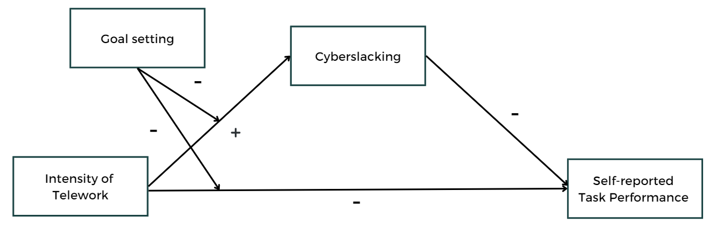

**Methods**

**Sample, Design and Procedures**

For the present study a sample of 339 people were recruited. Two inclusion criteria were defined. Firstly, people needed to work at least 3 days per week and people needed to work in average at least 10% of their work time outside the traditional office. The reason for choosing these two inclusion criteria is based on the fact that people need to work a certain number of hours, so that telework can have an impact on other work-related variables. Furthermore, only people who actually work part-time remotely can be considered, considering that this is the focus of the study. Exclusion criteria included students, people below the age of 18 and people who are self-employed, because in self-employment different dynamics come into play, which could influence the results. After considering the inclusion and exclusion criteria and excluding all the people with missing values, a total of 235 participants were included in the data analysis. The recommended number of participants was assessed prior to the study by a G*power analysis Version 3.1.9.7 (Faul et al., 2007), which recommended a minimum of 263 participants. The following parameters were used: F(1) = .05, α = .05, Power = .85, Number of predictors = 5. In previous research, these kinds of studies were expected to have small effect sizes, which is why F was set on .05 as the effect size. The participants in the sample had an average age of 31.50 (*SD* = 9.75) years, with 46.38% being male, 53.19% being female and 0.43% being non-binary or third gender. The participants had an average tenure in their current organization of 39.15 (*SD* = 56.81) months.

The study had a cross-sectional design with an online questionnaire and data was collected through Qualtrics. Participants were obtained through convenience and snowball sampling. These techniques were selected because there was a certain time constraint for the study, and they are simple methods that allow to generate a large sample in a short period of time (Etikan, 2016). Furthermore, the snowball sampling technique allows to reach people that are otherwise difficult to sample and further increases the sample size. To make sure the required sample size was reached, the data collection was done in a group, as this study was part of a larger research combining several studies. Participants were recruited from the personal network and contacted via email, direct messaging platforms, such as WhatsApp, and social media platforms, like LinkedIn, Facebook, and Instagram. All the participants were given a link to the same questionnaire. The questionnaire included, among other things, measures of intensity of telework, self-reported task performance, cyberslacking and goal setting. The other researchers were investigating similar topics; therefore, their constructs were also included in the questionnaire. Additionally, participants provided descriptives such as age, gender, and tenure. The questionnaire first gave the participants the choice to conduct it in English or Dutch. Then it provided them with general information regarding the study and they were asked to give consent to participate in the study. At any point participants could stop the questionnaire.

**Measures**

To test the hypotheses, four different constructs were operationalized. The different scales were included in one questionnaire. All items can be found in Appendix A.

***Intensity of Telework***

One single item measured the intensity of telework: “How much percent per week do you on average work outside from the traditional office?”. The participants indicated a percentage between 0-100 %, a higher score indicating higher intensity of telework. The percentage was used in order to take into account the relative relationship between remote work and work in the traditional office and allowed the inclusion of part-time workers in the study. This type of measure has been used in prior studies (Wiesenfeld et al., 1999; Golden & Veiga, 2005) and has been found to be an effective measurement for intensity of telework.

***Self-reported Task Performance***

Self-reported task performance was measured through the “Individual Work Performance Questionnaire” (IWPQ), developed by Koopmans et al. (2014). The IWPQ includes 27 items and is divided in three subscales, the first measuring task performance, the second contextual performance and the third counterproductive work behavior. The IWPQ was used, as is has shown good face and structural validity throughout prior research and a strong internal consistency (α = 0.78; Koopmans et al., 2014). A self-reported task performance scale was used, since it is difficult to measure performance objectively, and specifically this study was more interested in the self-perceived performance. For practical reasons, this study used the subscale task performance with only 5 items (e.g., “I was able to perform my work well with minimal time and effort.”). The items were scored on a 5-point rating scale ranging from 1 (*seldom*) to 5 (*always*), a higher score indicating a higher self-reported task performance. The Cronbach’s alpha coefficient of the task-performance subscale of Koopmans and colleagues (2014) is 0.82. The final items used to measure self-reported task performance used in this study showed a reliability of 0.73.

***Cyberslacking***

The amount of cyberslacking of the participants was measured through a 6-item scale, where the participants had to report how often they exhibit the behaviors described in the items. The scale was derived from the “Procrastination at Work Scale”, which is divided in three subscales, one of them being a 4-item cyberslacking scale (Metin et al., 2016). An example item was “I do online shopping during working hours”. Additional items were derived from Lim’s (2002) “Cyberloafing scale” to get a more complete measurement of cyberslacking (e.g., “I check and send non-work-related emails during working hours”). The items were scored on a 7-point Likert scale, with a scale anchor 0 (*Never*) and 6 (*Always*), a higher score indicating more cyberslacking behavior. The Cronbach’s alpha coefficient of the 4-item cyberslacking scale of Metin and colleagues (2016) is 0.69. The final items used to measure cyberslacking in this study showed a reliability of 0.74.

***Goal Setting***

Goal setting was measured with the “Goal Setting Formative Questionnaire” from Erickson and Noonan (2018). The scale consists originally of 19 items, divided in three subscales. The first looks at the meaningfulness of the goals, the second focuses on personal improvement and the third focuses on the goals being achievable and adaptable. In this study only the first subscale including the meaningfulness of goals was used. This subscale contains 6 items (e.g., “In my work I set short-term goals for myself”) and was scored on a 5-point Likert scale ranging from 1 (*Not like me at all*) to 5 (*Very much like me*), a higher score indicating more goal setting. The subscale of Erickson and Noonan (2018) has a Cronbach’s alpha coefficient of 0.81. The final items used to measure goal setting in this study showed a reliability of 0.82.

***Control Variables***

Three control variables were considered in this study. Firstly, prior research has shown that age is a relevant factor in the cyberslacking relationship (Vitak et al., 2011). It has been found that being younger positively predicts cyberslacking behavior, such as people who are younger cyberslack in average more than older people. Moreover, other studies have found age to be negatively correlated to telework, indicating that older people tend to telework less (Gajendran & Harrison, 2017). Furthermore, gender has also been found to have a significant relationship with cyberslacking, such as being male predicts higher cyberslacking behavior (Vitak et al., 2011). Finally, organizational tenure was considered as a control variable as it might affect telework outcomes. Prior research found that longer job tenure significantly led to higher telework intensity (Fonner & Roloff, 2010). Therefore, the three control variables age (in years), gender (1 = male, 2 = female) and tenure (in months) were considered in this research.

**Data Analysis**

The data in this study was analyzed using SPSS (Version 28.0). Firstly, it was checked if the data meets several required assumptions, by conducting a linear regression including all the variables. After checking the assumptions, the reliabilities of the scales were calculated. Beforehand, it was checked if there were items that needed to be reversed. If the reliability was sufficient the analysis was continued. Further, relevant descriptive statistics was computed, and a correlation analysis was done. To test the different hypothesis several analyses were performed. For hypothesis 1 a simple regression analysis was performed, for hypothesis 2 Model 4 in PROCESS macro was used and for hypotheses 3a and 3b Model 8 from PROCESS macro was used. Since the moderator included in the analysis is continuous, it was centered to -1SD, Mean, +1SD. In this study all p-values that are under 0.05 were considered as significant.

**Results**

**Assumption Check**

Firstly, six assumptions needed to be checked for this study. This included the absence of multicollinearity, the uncorrelatedness of residuals, a presence of extreme outliers, homoscedasticity, normality, and the assumption of linearity. The results of the assumption check can be found in Appendix B. As all the assumptions were met, the data could be used and further analyses were performed.

**Descriptive Statistics and Correlations**

After checking the assumptions, the means, standard deviations, and correlations including all the variables of the study were calculated. The results can be found in Table 1. Firstly, the control variable age was positively related to the employee’s tenure in months (*r* = .59, *p* < .001) which indicated that older employees tend to be in their current workplace longer than younger. Age also showed a significant negative relationship with cyberslacking (*r* = -.17, *p* = .008), which indicated, as expected, that older employees tend to cyberslack less than the younger employees. Contrary to the expectations, age did not significantly relate to intensity of telework (*r* = .02, *p* = .820). The second control variable gender, was also unexpectedly not significantly related to cyberslacking (*r* = -.12, *p* = .080). Finally, the last control variable, tenure was not found to be significantly related to intensity of telework (*r* = -.01, *p* = .927). Therefore, only age was included as a control variable.

When looking at the main variables and their correlations, only goal setting was significantly positively related to task performance (*r* = .19, *p* = .003) which means the more people set goals during work, the higher their self-reported task performance will be, compared to people with lower goal-setting scores. All the other main variables unexpectedly did not correlate. Intensity of telework did not have a significant relationship with neither self-reported task performance (*r* = .08, *p* = .208), nor cyberslacking (*r* = .07, *p* = .318). Also, Cyberslacking did not relate significantly with self-reported task performance (*r* = -.10, *p* = .135) or goal setting (*r* = -.09, *p* = .181).

**Table 1**

*Descriptive Statistics and Correlations for Study Variables*

|  |  |  |  |  |  |  |  |  |  |
| --- | --- | --- | --- | --- | --- | --- | --- | --- | --- |
| Variable | *M* | *SD* | 1. | 2. | 3. | 4. | 5. | 6. | 7. |
| 1. Gendera | 1.54 | 0.51 | - |  |  |  |  |  |  |
| 2. Age | 31.50 | 9.75 | -.02 | - |  |  |  |  |  |
| 3. Tenureb | 39.15 | 56.81 | .09 | .59*** | - |  |  |  |  |
| 4. Teleworkc | 43.54 | 23.79 | -.08 | .02 | -.01 | - |  |  |  |
| 5. Task Performanced | 3.68 | 0.64 | -.03 | .07 | .09 | .08 | - |  |  |
| 6. Cyberslacking | 3.31 | 1.91 | -.12 | -.17** | -.08 | .07 | -.10 | - |  |
| 7. Goal Setting | 3.81 | 0.65 | .09 | -.07 | -.11 | -.01 | .19** | -.09 | - |

*Note.* N = 234; a 1 = male, 2 = female. b Tenure in months. c Telework refers to the intensity of work outside the traditional office. d Task performance refers to participants’ self-reported performance.

* *p* < .05, ** *p* < .01, *** *p* < .001

**Confirmatory Analysis**

***Intensity of Telework and Self-reported Task Performance***

Hypothesis 1 states that intensity of telework is negatively related to self-reported task performance, so that more use of telework is related to a lower self-reported task performance. To test this a hierarchical regression analysis was conducted. An overview of the results is provided in Table 2. In a first step, the control variable of age was added to the model. There was no significant relationship found between the control variable and self-reported task performance *B* = .00, *t*(232) = 0.98, *p* = .326, 95%CI [-0.00, 0.01], *R*2 = .00, *F*(1, 233) = 1.00, *p* = .318. In a second step, intensity of telework was added to the model, which did not result in a significant increase in the explained variance of the model. Furthermore, the analysis did not show a significant positive relationship between the intensity of telework and self-reported task performance, *B* = .00, *t*(233) = 1.25, *p* = .214, 95%CI [-0.00, 0.01], *R*2 = .01, *F*(1, 232) = 1.56, *p* = .214. This means that people who telework more do not significantly show a lower self-reported task performance. Therefore, Hypothesis 1 was not supported.

**Table 2**

*Regression Analyses Testing the Effects of Intensity of Telework on Self-reported Task Performance*

|  |  |  |  |
| --- | --- | --- | --- |
| Variables | *B* | *R2* | Δ*R2* |
| Step 1 |  |  |  |
| Age | 0.00 | 0.00 | 0.00 |
| Step 2 |  |  |  |
| Age | 0.00 |  |  |
| Intensity of Telework | 0.00 | 0.01 | .01 |

*Note*. N = 234. Standardized regression coefficients are reported for the respective regression steps

* *p* < .05, ** *p* < .01, *** *p* < .001

***Intensity of Telework and Self-reported Task Performance Through Cyberslacking***

Hypothesis 2 states that cyberslacking mediates the negative relationship between intensity of telework and self-reported task performance. For this analysis, Model 4 in the PROCESS macro for SPSS (Hayes, 2013) with 2000 bootstrapped samples was used, where the control variable age was included. First of all, the total effect between intensity of telework and self-reported task performance was found to be not significant, *B* = 0.00, *SE* = 0.00, *t*(232) = 1.25, *p* = .214, 95%CI [-0.00, 0.01]. Furthermore, there was no relationship found between intensity of telework and cyberslacking, *B* = 0.01, *SE* = 0.01, *t*(232) = 1.05, *p* = .293, 95%CI [-0.00, 0.02]. When cyberslacking was entered into the model which included intensity of telework, the relationship between telework and self-reported task performance remained non-significant, *B* = 0.00, *SE* = 0.00, *t*(231) = 1.35, *p* = .180, 95%CI [-0.00, 0.01]. Furthermore, the relationship between cyberslacking and self-reported task performance was also not significant, *B* = -0.03, *SE* = 0.02, *t*(231) = -1.44, *p* = .152, 95%CI [-0.08, 0.01]. The indirect effect of intensity of telework on self-reported task performance via cyberslacking was found to be not significant as the 95% confidence interval did include zero, *Bindirect* = -0.00, 95%CI [-0.00, 0.00]. As such, the mediation model was not supported (see Figure 2).

**Figure 2**

*Relationship between Intensity of Telework and Self-reported Task Performance as Mediated by Cyberslacking*

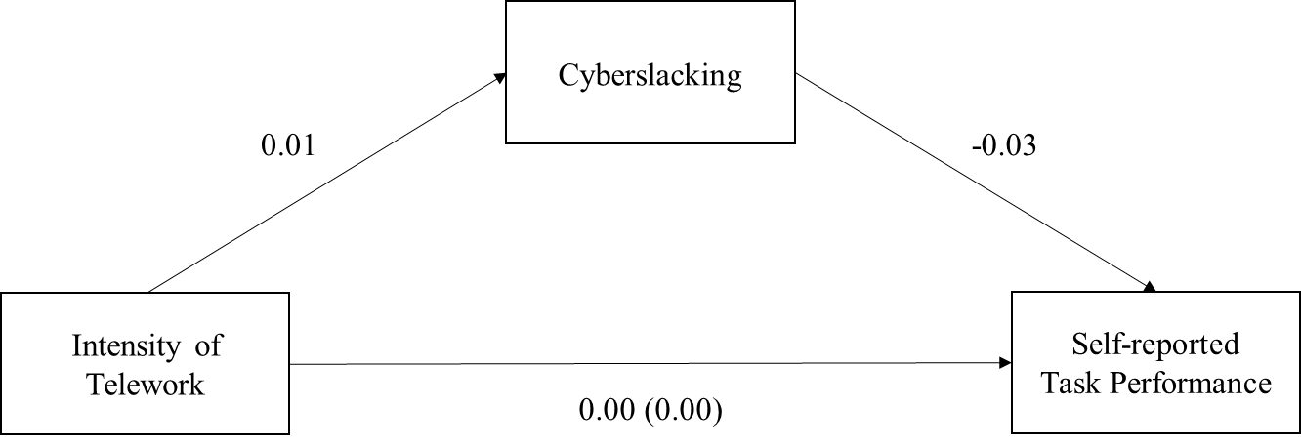

*Note*. Unstandardized regression coefficients are presented for all the paths. The regression coefficient between intensity of telework and self-reported task performance, while controlling for cyberslacking, is in parentheses.

* p < 0.05, ** p < .01.

***Intensity of Telework and Self-reported Task Performance Through Cyberslacking Moderated by Goal Setting***

Hypothesis 3a states that the negative relationship between intensity of telework and self-reported task performance is buffered by goal setting, such that the negative effect on task performance will decrease when people make use of goal setting. Hypothesis 3b states that the positive relationship between intensity of telework and cyberslacking is buffered by goal setting, so that cyberslacking will decrease when people make use of goal setting. For the analysis of both hypotheses, the control variable age was included. Model 1 and Model 8 in the PROCESS macro for SPSS (Hayes, 2013) with 2000 bootstrapped samples were used to test both hypotheses in form of a stage one moderation.

Firstly, the total effect of the interaction between intensity of telework and goal setting on self-reported task performance was not significant, *B* = -0.00, *SE* = 0.00, *t*(230) = -0.17, *p* = .869, 95%CI [-0.01, 0.00], *R*2 = .05, *F*(4, 230) = 2.98, *p* = .020. Nevertheless, what has been found is that the direct effect of goal setting on task performance was significant, *B* = -0.19, *SE* = 0.06, *t*(230) = 3.01, *p* = .003, 95%CI [0.07, 0.32], *R*2 = .05, *F*(4, 230) = 2.98, *p* = .020. Therefore, hypothesis 3a was partially supported.

When cyberslacking was entered into the model which also included the interaction term, the interaction effect was not significant, *B* = -0.00, *SE* = 0.00, *t*(229) = -0.44, *p* = .661, 95%CI [-0.01, 0.00]. Furthermore, the relationship between cyberslacking and self-reported task performance was also not significant, *B* = -0.03, *SE* = 0.02, *t*(229) = -1.23, *p* = .221, 95%CI [-0.07, 0.02]. Nevertheless, the effect of the interaction between intensity of telework and goal setting on cyberslacking was significant, *B* = -0.03, *SE* = 0.01, *t*(230) = -3.51, *p* < .001, 95%CI [-0.04, -0.01], Simple slopes analysis showed that when participants had a higher degree of goal setting (+1SD), the relationship between telework and cyberslacking was not significant, *B* = - 0.01, *SE* = 0.01, *t*(230) = -1.85, *p* = .066, 95%CI [-0.03, 0.00]. However, when goal setting was lower (-1SD) the relationship between telework and cyberslacking was significantly positive, *B* = 0.02, *SE* = 0.01, *t*(230) = 3.23, *p* = .001, 95%CI [0.01, 0.04]. This means, when people do not set goals, they tend to cyberslack more when working remotely (see also Figure 3). Therefore, hypothesis 3b was also partially supported.

**Figure 3**

*The Moderating Effect of Goal Setting on the Relationship Between Intensity of Telework and Cyberslacking*

Finally, the whole stage one moderation, including both hypothesis 3a and 3b, examining the effect of the interaction between telework and goal setting on self-rated task performance via cyberslacking was found to be not significant as the 95% confidence interval did include zero, *Bindirect* = 0.00, 95%CI [-0.00, 0.00]. The stage one moderation, including both hypotheses can be found in Figure 4.

**Figure 4**

*Moderating Effect of Goal setting on the Relationship Between Intensity of Telework and Self-reported Task Performance Through Cyberslacking*

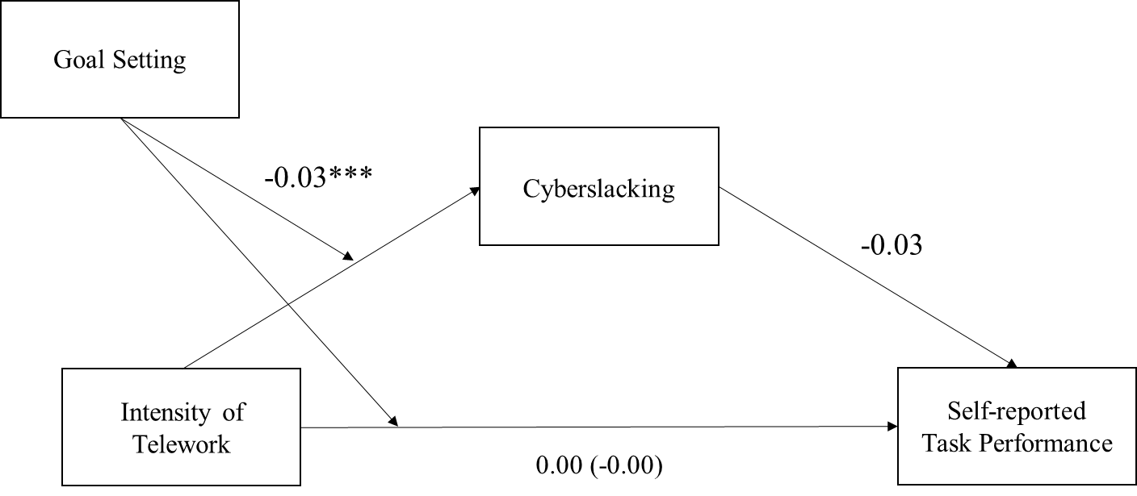

*Note.* Standardized regression coefficients for the interaction between intensity of telework and goal setting on self-reported task performance as mediated by cyberslacking. The regression coefficient for the interaction between intensity of telework and goal setting on self-reported task performance, while controlling for cyberslacking, is in parentheses.

* p < 0.05, ** p < .01, ***p < .001

**Exploratory Analysis**

The first hypothesis expected a linear relationship between intensity of telework and self-reported task performance. The result of the analysis did however not show such a relationship. Based on the too-much-of-a-good-thing effect one could also expect a possible curvilinear relationship between these two variables (Pierce & Aguinis, 2013). This means, when people work a moderate amount of time remotely, they can benefit from it. However, if it is too much or too little then these positive outcomes might change and they could experience several disadvantages (Pierce & Aguinis, 2013). Therefore, an exploratory analysis was conducted, with the aim to investigate whether the relationship between intensity of telework and self-reported task performance could be a curvilinear one. To test this, a curvilinear hierarchical regression analysis was conducted.

Before the analysis, the independent variable of intensity of telework was squared with itself. In a first step of the analysis, the control variable age was added to the model. In a second and third step, intensity of telework and intensity of telework squared were added to the model. The results of the analysis did not show a significant relationship between telework and self-reported task performance, *B =* 0.01, *t*(321) = 0.75, *p* = .457, 95%CI [-0.01, 0.02]. The same analysis did also not show a significant relationship between telework squared and the dependent variable *B =* 0.00, *t*(321) = 0.43 *p* = .664, 95%CI [-0.00, 0.00]. Therefore, no support was found for a curvilinear relationship between intensity of telework and self-reported task performance. An overview of the results is provided in Table 3.

**Table 3**

*Regression Analyses Testing the Effects of Intensity of Telework on Self-reported Task Performance*

|  |  |  |  |
| --- | --- | --- | --- |
| Variables | *B* | *R2* | Δ*R2* |
| Step 1 |  |  |  |
| Age | 0.00 | 0.00 | 0.00 |
| Step 2 |  |  |  |
| Age | 0.00 |  |  |
| Intensity of Telework  (Intensity of Telework)2 | 0.01  -0.00 | 0.01  0.01 | 0.01  0.00 |

*Note*. N = 234. 2 = squared intensity of telework variable. Standardized regression coefficients are reported for the respective regression steps

* *p* < .05, ** *p* < .01, *** *p* < .001

**Discussion**

The study aimed to explore the relationship between telework, cyberslacking and task performance, building on recent research suggesting potential pitfalls of remote working. The introductory section highlighted the common belief that working remotely increases productivity by reducing distractions. However, the extensive use of technology and internet, also for non-work purposes raises questions about the actual level of distraction experienced by individuals while teleworking. Therefore, this study hypothesized that increased cyberslacking would represent the underlying mechanism between telework and task performance, and the reason why people who work from home might show lower performance. In addition, the study introduced goal setting as a moderator, suggesting that individuals who set specific and challenging goals would engage in less cyberslacking, thus buffering the negative relationship. The results of the study, however, did only partially support these hypotheses.

**The Impact of Goal Setting on Cyberslacking and Performance when Teleworking**

The main finding of this study is the significant relationship between the interaction of goal setting and task performance on cyberslacking, specifically how goal setting can buffer the positive relationship between the two variables. The study found that when people do not set goals, they tend to cyberslack more when working remotely. The contrary that people who set goals tend to cyberslack less when working remotely has not found to be significance, nevertheless when looking at high level of goal setting the relationship was almost significantly positive at a p = .066, which is marginal. Therefore, it could be a power issue and that it did not pick up the effect. These results indicate that if a person does not set specific, clear and meaningful goals they get distracted quicker and start using the technologies and internet they have available during work for non-work related purposes.

The second main finding of this study is the significant relationship between goal setting and self-reported task performance. The study found a direct effect between these two variables, meaning that people when they set goals for themselves during work, they generally show a higher self-reported task performance. This finding was not surprising, as there is a lot of empirical and theoretical evidence supporting this assumption (Champagne & McAfee, 1989; Locke et al., 1981; Mento et al., 1987). It has been found to be a strong motivator that does not only lead to people focus more on their goals, but also to achieve them and therefore show a higher overall performance (Mento et al., 1987). They have also found when setting goals, people tend to work harder and are better able to organize their work, and therefore show increased productivity.

However, besides the direct effect this study has not found a significant relationship of the interaction of goal setting and telework on performance and neither of the full first stage moderation model. There could be several reasons why these relationships have not been found. Firstly, the other analyses have already not found a significant direct relationship between the variables. For example, hypothesis 1 looked at the relationship between telework and task performance which was not significant. This could be the reason why also the interaction with goal setting was not significant. Furthermore, there could be external factors that were not considered in the study that could have influences the relationship. Factors such as organizational culture, job characteristics or leadership could play a role in shaping the relationship between goal setting, telework and task performance (Golden et al., 2006; Gajendran & Harrison, 2007). Studies have also found that individual factors like personality traits or work experience can influence on how goal setting effects on performance in the interaction with telework (Latham & Locke, 2007; Klein & Lee, 2006; Bronkhorst et al., 2015)*.* Future research should therefore investigate this relationship and include these factors to get a clearer picture of the relationship.

***Theoretical Implications***

The study’s findings have important theoretical implications for the understanding of the relationship between telework, goal setting and cyberslacking, and are partially in line with the suggested theoretical frameworks. The first one is the JD-R framework of Demerouti et al (2001). This model looks at how people have different demands ad resources when working and how one can use personal resources to overcome these. In this study telework as well as cyberslacking were consider job demands (Lavoie & Pychyl, 2001; Koch & Nafziger, 2016). Telework increases flexibility and autonomy but is also linked to a lack of structure and more decision-making processes which can lead to a higher change of getting distracted (Lavoie & Pychyl, 2001). Cyberslacking as it is a type of distraction from work and a temptation one needs to resist (O’Neill et al., 2014; Koch & Nafziger, 2016). Furthermore, Goal setting can be seen as a personal resource for several reasons (Xanthopoulou et al., 2007; Grover et al., 2018). Firstly, it helps regulate the work and stay focused on the task at hand. Secondly it represents a way to self-regulate and self-control to resist the temptations. Therefore, it can be used as a strategy to cope with the challenges people encounter when working remotely and prevent cyberslacking (Demerouti et al., 2001).

The results also align with the goal setting theory of Locke and Latham (2006), which explains how goals can influence the intrinsic motivation of employees. They state that people are more motivated to focus on their work when they set specific, clear, challenging, and meaningful goals. This eventually leads to people getting less distracted and staying more focused on the work at hand. Thus, goal setting plays a critical role in maintaining motivation and overcoming challenges, especially in the context of telework and cyberslacking. If the motivation to work on the tasks is higher, people eventually get less distracted and engage in less cyberslacking (Locke & Latham, 2006).

**The Relationship between Telework and Task Performance**

Besides the significance that has been found between the interaction of goal setting and telework on cyberslacking and the direct relationship between goal setting and task performance, all other hypotheses have not been supported. The first hypothesis of this study examined the direct relationship between the intensity of telework and self-reported task performance. Despite several studies indicating a negative relationship between telework and self-reported task performance (Beno & Hvorecky, 2021; Kubicek et al., 2017; Langfred, 2004), the present study found no support for this. The hypothesis was based on the assumption that when working remotely people tend to have very high level of autonomy which can lead to a depletion of resources and therefore lower level of performance (Pierce & Aguinis, 2013). This assumption was derived from the too-much-of-a-good-thing theory from Pierce and Aguinis (2013) and the self-depletion theory of Baumeister and colleagues (1998).

One factor that could explain why no relationship has been found, is that autonomy has not been included as a variable in the analysis. Autonomy is a key concept in the theoretical framework and was used to support the assumption that too much telework would decrease performance (Pierce & Aguinis, 2013). In this study only intensity of telework was measured, as it was connected to increased autonomy in the literature (Gajendran & Harrison, 2017). In order to get a clearer picture, future research should include autonomy in the analysis and add it as a control variable or an interaction variable with telework.

Furthermore, another reason why it might not have been significant is, that the relationship between telework and task performance is not linear. The TMGT effect suggests a curvilinear relationship between these two variables (Pierce & Aguinis, 2013). This means when people work remotely, moderate amount of autonomy is in fact beneficial, only after it has reached a certain threshold it can become counterproductive and negatively influence performance. Thus, an exploratory analysis was conducted where the curvilinear relationship between intensity of telework and self-reported task performance was tested. The analysis did also not find a significant relationship. Reasons for that could be that even though autonomy has been linked with intensity of telework, they are not interchangeable and maybe other factors play a role in this relationship.

An argument for the lack of significant findings could be that there are several other factors influencing performance which have not been examined in this study. This research focused on the direct effect of telework on task performance, while there might be other variables playing a role. The literature suggests that job characteristics, employee’s personal characteristics and situational factors can have an influence on the job performance (O’Neill et al., 2009; Kubicek et al., 2017). Kubicek and colleagues (2017) found that certain type of jobs, such as those with high time pressure can lower the performance, while those with lower time pressure can increase it. Other research states that the amount of work influences the effect on performance, such as having less to do will decrease your performance, while a high amount of work will influence the performance positively, as there is less room for distractions (Beno & Hvorecky, 2021). The same researchers also looked into personal characteristics such as feeling comfortable with the usage of technology at work. They found that people tend to show better performance when having the possibility to work remotely, but only, if they feel comfortable with it. This could be relevant especially for older people that are not as used to the technologies needed when working remotely, compared to younger people (Turner et al., 2007). Another relevant personal factor is the presence of a work-from-home routine, meaning that people who create for themselves a strong routine show higher performance than people who lack a good routine (Beno & Hvorecky, 2021). This is also related with goal setting, which helps to structure the work (Ent et al., 2012). Finally, situational factors like having children at home during working hours, can also decrease performance (Beno & Hvorecky, 2021). In conclusion, there are a lot of variables that influence performance besides teleworking and the feeling of autonomy, which have not been looked at in this study. Future research should therefore include other variables in the relationship to get a more complete picture.

***Theoretical Implications***

A theoretical implication for the literature on telework is the relevance of autonomy. The too-much-of-a-good-thing effect from Pierce and Aguinis (2013) highlights the importance of measuring autonomy as a key concept in understanding the relationship between telework and task performance. While this study only focused on the intensity of telework, future research should include the direct measure of autonomy and include it as a control variable. Furthermore, the same theory suggested a curvilinear relationship between autonomy and task performance. Nevertheless, the exploratory analysis that explored a curvilinear relationship between telework and performance has not been found, suggesting the need for further investigation in this area. Finally, the findings and empirical evidence highlight that telework and the impact on task performance cannot be solely attributed to one factor. It is a much more complex phenomenon that can be influenced by a combination of factors. A holistic approach should be taken in future research to understand the nature of telework better.

**The Relationship of Cyberslacking and Self-reported Task Performance**

Finally, the last relevant construct in this study is cyberslacking. It has been introduced as a possible distractor, that can influence the positive effects that telework might have on performance (Lavoie & Pychyl, 2001). Contrary to previous research and theory indicating the negative effect of cyberslacking on task performance, the results of this study found no significant relationships. Nevertheless, even though the correlation between cyberslacking and task performance was insignificant the direction of the relationship between cyberslacking and task performance was found to be negative.

The lack of evidence supporting the hypothesis could be explained through other factors. Firstly, besides cyberslacking, people might face other distractions at home. For example, people might have children or roommates working from home, which might be even more distracting than cyberslacking and decrease the performance (Beno & Hvorecky, 2021). This could be an indication that cyberslacking might not be the only distracting factor when working remotely, and therefore the relationship was not found because there were factors missing in the analysis. Furthermore, a possible explanation could also be that cyberslacking does not influence a person’s performance but rather the other way around. O’Neill et al. suggest that perceived performance together with unsatisfaction with the job is what leads to a higher cyberslacking behavior in people, and not the other way around. It would be interesting in future research to conduct an experiment to see the direction of the relationship and maybe also include satisfaction in the analysis. In such a case, self-reported performance could be manipulated, by for example altering the complexity of a task of the participants (Kruger & Dunning, 1999). In an experiment like this, ethical guidelines would need to be considered and ensured that the manipulation aligns with the overall objectives of the study and the well-being of participants.

***Theoretical Implications***

In this study cyberslacking is looked at through the lens of the cognitive load and the self-depletion theory (Sweller, 1994; Baumeister et al., 1998). The research looked at cyberslacking as a cognitive overload and connected it to lower performance, as there are no more resources left when cyberslacking for work related tasks. However, literature suggests that it could also be seen as a recovery. Some theorists have suggested that using the internet for non-work-related activities during office hours could actually be helpful for employees (Lim & Chen, 2012; Stanton, 2002). This is because it can provide a short break from work, give employees the chance to do other tasks that they need to do and therefore reduce stress, allow for socializing with colleagues, and help employees cope with their emotions (Lim & Chen, 2012). These findings do not imply that cyberslacking is positive and should be encouraged, but rather that some non-work-related online activities can allow people to get some rest from work and motivate them to perform better and could be indeed useful in a balanced way (Lim & Chen, 2012).

Finally, another theoretical implication is that the relationship between cyberslacking and task performance is not linear but rather curvilinear (She & Li, 2022). The study of She and Li (2022) found evidence for the curvilinear relationship and based it on the effort-recovery model. Thus, they found that when people cyberslack in a moderate amount it could actually have positive effects on task performance, while too little and too much were negatively related. This is again explained through the assumption that cyberslacking is seen as a recovery and a break from work (She & Li, 2022). Future research could further investigate this relationship by checking for curvilinearity in the relationship between cyberslacking and task performance.

**Strengths and Limitations**

This study has several strengths and limitations. Firstly, the study involved the gathering of data from a diverse range of participants, which includes participants from different companies, sectors, backgrounds as well as age groups. This comprehensive approach enhances the generalizability of the findings. Moreover, the study used participants from at least two separate countries, which includes a cross-cultural perspective. This increases the external validity of the study and allows for a broader understanding (Findley et al., 2021). Furthermore, the study examined the mediating role of cyberslacking and the moderating effect of goal setting, indicating a more comprehensive and nuanced research (Hayes, 2013). Finally, the study discusses several theoretical as well as practical implications of its findings. This connection between research and practice shows the relevance of this study.

There are also several limitations that need to be addressed in this study. The fact that this study is cross-sectional in nature represents one limitation. This means that data was collected only once, without any interventions or manipulations, preventing the drawing of definitive causal conclusions from the findings. A possible solution to address this limitation would be to conduct a longitudinal survey to infer causal relationships, as suggested by previous research (Rindfleisch et al., 2008). Another way how causality could be established is through experimental designs, where the variables are manipulated (Behi & Nolan, 1996). In this study cyberslacking was measure with a self-reported questionnaire, while in an experimental design this variable could have been manipulated and the effects observed on other variables. Another variable that could be manipulated is goal setting. By randomly assigning participants to different groups, researchers can control for extraneous variables and determine whether changes in the predictors cause changes in the dependent variables (Behi & Nolan, 1996).

A final limitation is that the measuring methods might have influenced the results. Firstly, for practical reasons, many scales had to be shortened, which may have caused that the items of the scales did not always fully capture the concepts. Moreover, all the variables were measured with self-reported scales. This can be problematic because there are biases that influence how someone answers the questions (Rosenman et al., 2011). Firstly, the response bias describes a systematic error or distortion in how people answer survey questions (Paulhus, 1991). It happens when participants give responses that are not a real reflection of their true beliefs or actions, which can happen because of social desirability. In this study the response bias might have influenced some people to give answers that are not really accurate, but rather socially desirable. Future research could try to minimize this bias by designing neutral survey questions or analyse the data for potential biases, which has not been done in this study (Paulhus, 1991). Furthermore, a second bias that might have influenced the responses in the self-reported questionnaire is the recall bias (Basso et al., 1997). This bias can occur when participants in a study do not accurately remember past events or experiences. As mentioned in the beginning of this study, most people are not even aware how much time they spend on the internet. Therefore, it is possible that people do not accurately remember the amount of cyberslacking when answering the questionnaire. To prevent these limitations, future research could measure cyberslacking and task performance in different ways. Instead of subjective self-reported task performance, the objective performance could be measured by including peers or supervisors in the study (Bommer et al., 1995). Moreover, cyberslacking could be measured with actual screentime and activity (Vizcaino et al., 2019). This would lead to a more objective view on their performance and therefore minimize some of the biases.

**Practical Implication**

What does this mean in the everyday life on teleworkers? Some important practical implications of this research can be suggested to organizations, especially when considering the finings regarding goal setting. The results suggest that people who telework tend to cyberslack more when they do not set specific goals. Therefore, organizations may want to encourage remote workers to set specific, clear, challenging and meaningful goals, which would help them stay focused and reduce the probability of cyberslacking (Locke & Latham, 2006). It also helps them to organize their work and improve their overall performance (Mento et al., 1987). Furthermore, organizations could offer trainings and resources on effective goal-setting techniques, to help employees set meaningful goals and give advice on how to deal with distractions that can influence their behavior and possibly their performance (Latham & Kinne, 1974). Similarly, employers could encourage the usage of working routines when working remotely, by providing guidance on time management or work-life balance (Beno & Hvorecky, 2021). This would help employee to structure their work and minimize distractions.

Secondly, even though the analysis of this study has not found a significant relationship between cyberslacking and performance, theory and prior research suggests that it can be related to potential issues when working remotely. Organizations can educate employees about the risks of excessive non-work related internet use and offer strategies to minimize distractions (Lavoie & Pychyl, 2001). This may include establishing guidelines or policies on internet use during working hours, encouraging self-regulation, and providing tools or software to track online activities (Flanigan & Kiewra, 2018).

Furthermore, organizations need to consider how job characteristics and individual differences might influence people’s work, especially when teleworking. Factors like time pressure and workload, as well as personality traits and characteristics can influence task performance (O’Neill et al., 2009; Kubicek et al., 2017). Therefore, employers could consider providing flexibility and support to their employees to optimize performance. All in all, organizations need to be aware that telework can present unique challenges compared to office-based work.

**Conclusion**

The aim of this study was to find support of the shift from benefits to drawbacks of telework. This is especially relevant due to the recent increase in remote work due to the Covid-19 pandemic. Building on existing literature, this research investigated the negative correlation between telework and task performance by proposing cyberslacking as an underlying mechanism. Nevertheless, this main assumption was not significant and therefore the hypothesis was not supported. However, based on literature it is still important to consider the dangers of cyberslacking and also other potential distractors that may influence performance. Furthermore, there is some empirical evidence that supports the assumption that cyberslacking might actually be beneficial in certain context. Evidently, the concept of telework and cyberslacking are complex and multifaceted and further research is needed to get a clear picture of the benefits and drawbacks.

Finally, goal setting was introduced in this research as a buffer for this negative relationship, such as when people set specific, clear, challenging, and meaningful goals they engage in less cyberslacking and show a better performance. The results of this study showed that not only did goal setting have a direct positive relationship with task performance, but also as a moderator on cyberslacking. This highlights the importance of promoting such strategies among teleworkers to minimize negative outcomes. Providing support and guidance for employees in setting goals can boost their motivation, keep them focused, and overall increase their productivity while working remotely.

Understanding the complex relationships between telework, cyberslacking, goal setting, and performance is crucial in an era where remote work prevails. By recognizing the potential drawbacks of teleworking and implementing strategies to handle distractions, the full potential of remote working can be unlocked and productivity can be ensured.

**References**

Alharthi, S., Levy, Y., Wang, L., & Hur, I. (2019). Employees’ mobile cyberslacking and their commitment to the organization. *Journal of Computer Information Systems*, *61*(2), 141–153. https://doi.org/10.1080/08874417.2019.1571455

Baltes, B. B., Briggs, T. E., Huff, J. W., Wright, J. A., & Neuman, G. A. (1999). Flexible and compressed workweek schedules: A meta-analysis of their effects on work-related criteria*. Journal of Applied Psychology, 84*(4), 496–513. https://doi.org/10.1037/0021-9010.84.4.496

Basso, O., Olsen, J., Bisanti, L., & Karmaus, W. (1997). The performance of several indicators in detecting recall bias. *Epidemiology*, *8*(3), 269. https://doi.org/10.1097/00001648-199705000-00007

Baumeister, R. F., Bratslavsky, E., Muraven, M., & Tice, D. M. (1998). Ego depletion: Is the active self a limited resource? *Journal of Personality and Social Psychology, 74*(5), 1252–1265. https://doi.org/10.1037/0022-3514.74.5.1252

Bannert, M. (2002). Managing cognitive load-recent trends in cognitive load theory. *Learning and Instruction, 12*(1), 139–146. https://doi.org/10.1016/s0959-4752(01)00021-4

Behi, R., & Nolan, M. (1996). Causality and control: threats to internal validity. *British Journal of Nursing, 5*(6), 374–377. https://doi.org/10.12968/bjon.1996.5.6.374

Bélanger, F. (1999). Workers’ propensity to telecommute: An empirical study. *Information & Management*, *35*(3), 139–153. doi:10.1016/s0378-7206(98)00091-3

Beno, M., & Hvorecky, J. (2021). Data on an Austrian company’s productivity in the pre-covid-19 era, during the lockdown and after its easing: To work remotely or not? *Frontiers in Communication, 6*. https://doi.org/10.3389/fcomm.2021.641199

Bommer, W. H., Johnson, J. N., Rich, G. A., Podsakoff, P. M., & MacKenzie, S. B. (1995). On the interchangeability of objective and subjective measures of employee performance: A meta-analysis. *Personnel Psychology, 48*(3), 587–605. https://doi.org/10.1111/j.1744-6570.1995.tb01772.x

Bronkhorst, B., Steijn, B., & Vermeeren, B. (2015). Transformational leadership, goal setting, and work motivation. *Review of Public Personnel Administration, 35*(2), 124–145. https://doi.org/10.1177/0734371x13515486

Champagne, P. J., & McAfee, R. B. (1989). Motivating strategies for performance and productivity: a guide to human resource development. *Choice Reviews Online, 26*(11), 26–6341. https://doi.org/10.5860/choice.26-6341

Demerouti, E., Bakker, A. B., Nachreiner, F., & Schaufeli, W. B. (2001). The job demands-resources model of burnout. *Journal of Applied Psychology*, *86*(3), 499–512. https://doi.org/10.1037/0021-9010.86.3.499

Eaton, S. C. (2003). If you can use them: Flexibility policies, organizational commitment, and perceived performance. *Industrial Relations*, *42*(2), 145–167. https://doi.org/10.1111/1468-232x.00285

Ent, M. R., Baumeister, R. F., & Vonasch, A. J. (2012). Power, leadership, and self-regulation. *Social and Personality Psychology Compass, 6*(8), 619–630. https://doi.org/10.1111/j.1751-9004.2012.00446.x

Erickson, A.S., & Noonan, P.M. (2018*). Goal setting formative questionnaire. In The skills that matter: Teaching interpersonal and intrapersonal competencies in any classroom*. Corwin.

Etikan, I. (2016). Comparison of convenience sampling and purposive sampling. *American Journal of Theoretical and Applied Statistics, 5*(1), 1. https://doi.org/10.11648/j.ajtas.20160501.11

Faul, F., Erdfelder, E., Lang, A. G., & Buchner, A. (2007). G*Power 3: A flexible statistical power analysis program for the social, behavioral, and biomedical sciences. *Behavior Research Methods, 39*(2), 175–191. https://doi.org/10.3758/bf03193146

Ferrari, J. R., Swanson, H. L., & Patel, D. A. (2021). The impact of office clutter on remote working:" I can't work with all this stuff!". *North American Journal of Psychology, 23*(1), 155-172.

Findley, M. G., Kikuta, K., & Denly, M. (2021). External validity. *Annual Review of Political Science, 24*(1), 365–393. https://doi.org/10.1146/annurev-polisci-041719-102556

Flanigan, A. E., & Kiewra, K. A. (2018). What college instructors can do about student cyber-slacking. *Educational Psychology Review, 30*(2), 585–597. https://doi.org/10.1007/s10648-017-9418-2

Fonner, K. L., & Roloff, M. E. (2010). Why teleworkers are more satisfied with their jobs than are office-based workers: When less contact is beneficial. *Journal of Applied Communication Research*, *38*(4), 336–361. https://doi.org/10.1080/00909882.2010.513998

Gajendran, R. S., & Harrison, D. A. (2007). The good, the bad, and the unknown about telecommuting: Meta-analysis of psychological mediators and individual consequences. *Journal of Applied Psychology*, *92*(6), 1524–1541. https://doi.org/10.1037/0021-9010.92.6.1524

Garrett, R. K., & Danziger, J. N. (2008). On Cyberslacking: Workplace status and personal internet use at work. *Cyberpsychology & Behavior, 11*(3), 287–292. https://doi.org/10.1089/cpb.2007.0146

George, T. J., Atwater, L. E., Maneethai, D., & Madera, J. M. (2022). Supporting the productivity and wellbeing of remote workers. *Organizational Dynamics*, *51*(2), 100869. https://doi.org/10.1016/j.orgdyn.2021.100869

Golden, T. D., & Veiga, J. F. (2005). The impact of extent of telecommuting on job satisfaction: Resolving inconsistent findings. *Journal of Management, 31*(2), 301–318. https://doi.org/10.1177/0149206304271768

Golden, T. D., Veiga, J. F., & Simsek, Z. (2006). Telecommuting’s differential impact on work-family conflict: Is there no place like home? *Journal of Applied Psychology, 91*(6), 1340–1350. https://doi.org/10.1037/0021-9010.91.6.1340

Graydon, J., & Eysenck, M. W. (1989). Distraction and cognitive performance. *European Journal of Cognitive Psychology, 1*(2), 161–179. https://doi.org/10.1080/09541448908403078

Greer, T. W., & Payne, S. C. (2014). Overcoming telework challenges: Outcomes of successful telework strategies. *The Psychologist-Manager Journal*, *17*(2), 87–111. https://doi.org/10.1037/mgr0000014

Grover, S. A., Teo, S. T., Pick, D., Roche, M., & Newton, C. (2018). Psychological capital as a personal resource in the JD-R model. *Personnel Review, 47*(4), 968–984. https://doi.org/10.1108/pr-08-2016-0213

Hayes, A. F. (2013). *Introduction to mediation, moderation, and conditional process analysis: A regression-based approach*. Guilford Press.

Heiden, M., Widar, L., Wiitavaara, B., & Boman, E. (2020). Telework in academia: associations with health and well-being among staff. *Higher Education, 81*(4), 707–722. https://doi.org/10.1007/s10734-020-00569-4

Hernandez, Y. A. (2020). Remote workers during the COVID-19 lockdown. What are we missing and why is important*. Journal of Occupational & Environmental Medicine, 62*(11), 669–672. https://doi.org/10.1097/jom.0000000000002018

Howarth, J. (2023). *Alarming Average Screen Time Statistics (2023)*. Exploding Topics. https://explodingtopics.com/blog/screen-time-stats

Hunter, P. (2018). Remote working in research. *EMBO Reports*, *20*(1). https://doi.org/10.15252/embr.201847435

Junco, R., & Cotten, S. R. (2012). The relationship between multitasking and academic performance. *Computers & Education, 59*(2), 505–514. https://doi.org/10.1016/j.compedu.2011.12.023

Kim, J. S., & Hamner, W. C. (1976). Effect of performance feedback and goal setting on productivity and satisfaction in an organizational setting. *Journal of Applied Psychology*, *61*(1), 48–57. https://doi.org/10.1037/0021-9010.61.1.48

Klein, H. J., & Lee, S. C. (2006). The effects of personality on learning: The mediating role of goal setting. *Human Performance, 19*(1), 43–66. https://doi.org/10.1207/s15327043hup1901_3

Koch, A., & Nafziger, J. (2016). Gift exchange, control, and cyberloafing: A real-effort experiment. *Journal of Economic Behavior and Organization, 131*, 409–426. https://doi.org/10.1016/j.jebo.2016.09.008

Koopmans, L., Bernaards, C., Hildebrandt, V., van Buuren, S., Beek, V. D., & Vet, D. (2014). Improving the Individual Work Performance Questionnaire using Rasch analysis. *Journal of Applied Measurement, 15*(2), 160-75. https://doi.org/10.1136/oemed-2013-101717.51

Kruger, J., & Dunning, D. (1999). Unskilled and unaware of it: How difficulties in recognizing one’s own incompetence lead to inflated self-assessments. *Journal of Personality and Social Psychology, 77*(6), 1121–1134. https://doi.org/10.1037/0022-3514.77.6.1121

Kubicek, B., Paškvan, M., & Bunner, J. (2017). The bright and dark sides of job autonomy. *Springer eBooks*, 45–63. https://doi.org/10.1007/978-3-319-54678-0_4

Langfred, C. W. (2004). Too much of a good thing? Negative effects of high trust and individual autonomy in self-managing teams*. Academy of Management Journal, 47*(3), 385–399. https://doi.org/10.5465/20159588

Latham, G. P., & Locke, E. A. (2007). New developments in and directions for goal-setting research. *European Psychologist, 12*(4), 290–300. https://doi.org/10.1027/1016-9040.12.4.290

Latham, G. P., & Kinne, S. B. (1974). Improving job performance through training in goal setting. *Journal of Applied Psychology, 59*(2), 187–191. https://doi.org/10.1037/h0036530

Latham, G. P., & Yukl, G. A. (1975). A review of research on the application of goal setting in organizations. *Academy of Management Journal*, *18*(4), 824–845. https://doi.org/10.5465/255381

Lavoie, J. a. A., & Pychyl, T. A. (2001). Cyberslacking and the procrastination superhighway. *Social Science Computer Review, 19*(4), 431–444. https://doi.org/10.1177/089443930101900403

Li, L., & Lin, T. T. C. (2019). Smartphones at work: A qualitative exploration of psychological antecedents and impacts of work-related smartphone dependency. *International Journal of Qualitative Methods*, *18*, 160940691882224. https://doi.org/10.1177/1609406918822240

Lim, V. G., & Chen, D. J. Q. (2012). Cyberloafing at the workplace: gain or drain on work? *Behaviour & Information Technology, 31*(4), 343–353. https://doi.org/10.1080/01449290903353054

Lim, V. K. G. (2002). The IT way of loafing on the job: cyberloafing, neutralizing and organizational justice. *Journal of Organizational Behavior, 23*(5), 675–694. https://doi.org/10.1002/job.161

Locke, E. A., & Latham, G. P. (2006). New directions in goal-setting theory. *Current Directions in Psychological Science*, *15*(5), 265–268. https://doi.org/10.1111/j.1467-8721.2006.00449.x

Locke, E. A., Shaw, K. N., Saari, L. M., & Latham, G. P. (1981). Goal setting and task performance: 1969–1980. *Psychological Bulletin, 90*(1), 125–152. https://doi.org/10.1037/0033-2909.90.1.125

Mento, A. J., Steel, R. P., & Karren, R. J. (1987). A meta-analytic study of the effects of goal setting on task performance: 1966–1984. *Organizational Behavior and Human Decision Processes*. https://doi.org/10.1016/0749-5978(87)90045-8

Metin, U. B., Taris, T. W., & Peeters, M. C. (2016). Measuring procrastination at work and its associated workplace aspects. *Personality and Individual Differences, 101*, 254–263. https://doi.org/10.1016/j.paid.2016.06.006

Morgeson, F. P., Delaney-Klinger, K., & Hemingway, M. A. (2005). The importance of job autonomy, cognitive ability, and job-related skill for predicting role breadth and job performance. *Journal of Applied Psychology, 90*(2), 399–406. https://doi.org/10.1037/0021-9010.90.2.399

Müller, T., & Niessen, C. (2019). Self‐leadership in the context of part‐time teleworking. *Journal of Organizational Behavior, 40*(8), 883–898. https://doi.org/10.1002/job.2371

Nicholson, D. B., Parboteeah, D. V., Nicholson, J. A., & Valacich, J. S. (2005). Using distraction-conflict theory to measure the effects of distractions on individual task performance in a wireless mobile environment. *Hawaii International Conference on System Sciences.* https://doi.org/10.1109/hicss.2005.657

Nusrat, A., He, Y., Luqman, A., Waheed, A., & Dhir, A. (2021). Enterprise social media and cyber-slacking: A Kahn’s model perspective. *Information & Management*, *58*(1), 103405. https://doi.org/10.1016/j.im.2020.103405

O’Neill, T. A., Hambley, L. A., & Bercovich, A. (2014). Prediction of cyberslacking when employees are working away from the office. *Computers in Human Behavior*, *34*, 291–298. https://doi.org/10.1016/j.chb.2014.02.015

Paulhus, D. L. (1991). Measurement and Control of Response Bias. *Elsevier eBooks,* 17–59. https://doi.org/10.1016/b978-0-12-590241-0.50006-x

Pierce, J. R., & Aguinis, H. (2013). The too-much-of-a-good-thing effect in management. *Journal of Management, 39*(2), 313–338. https://doi.org/10.1177/0149206311410060

Raghuram, S., & Wiesenfeld, B. (2004). Work-nonwork conflict and job stress among virtual workers. *Human Resource Management*, *43*(2–3), 259–277. https://doi.org/10.1002/hrm.20019

Rindfleisch, A., Malter, A. J., Ganesan, S., & Moorman, C. (2008). Cross-sectional versus longitudinal survey research: Concepts, findings, and guidelines. *Journal of Marketing Research, 45*(3), 261–279. https://doi.org/10.1509/jmkr.45.3.261

Rosenman, R., Tennekoon, V., & Hill, L. G. (2011). Measuring bias in self-reported data. *International Journal of Behavioural and Healthcare Research, 2*(4), 320. https://doi.org/10.1504/ijbhr.2011.043414

Rubin, R. S., Dierdorff, E. C., & Bachrach, D. G. (2012). Boundaries of citizenship behavior: Curvilinearity and context in the citizenship and task performance relationship. *Personnel Psychology, 66*(2), 377–406. https://doi.org/10.1111/peps.12018

Sahut, J. M., & Lissillour, R. (2023). The adoption of remote work platforms after the Covid-19 lockdown: New approach, new evidence. *Journal of Business Research, 154*, 113345. https://doi.org/10.1016/j.jbusres.2022.113345

Schachter, H. L. (2010). Objective and subjective performance measures. *Administration & Society, 42*(5), 550–567. https://doi.org/10.1177/0095399710378080

She, Z., & Li, Q. (2022). When too little or too much hurts: Evidence for a curvilinear relationship between cyberloafing and task performance in public organizations. *Journal of Business Ethics*, *183*(4), 1141-1158. https://doi.org/10.1007/s10551-022-05038-9

Stanton, J. M. (2002). Company profile of the frequent internet user. *Communications of the ACM, 45*(1), 55–59. https://doi.org/10.1145/502269.502297

Swanson, H. L. (1987). Information Processing Theory and learning disabilities. *Journal of Learning Disabilities, 20*(1), 3–7. https://doi.org/10.1177/002221948702000102

Sweller, J. (1994). Cognitive load theory, learning difficulty, and instructional design. *Learning and Instruction, 4*(4), 295–312. https://doi.org/10.1016/0959-4752(94)90003-5

Tandon, A., Kaur, P., Ruparel, N., Islam, J. U., & Dhir, A. (2021). Cyberloafing and cyberslacking in the workplace: systematic literature review of past achievements and future promises. *Internet Research, 32*(1), 55–89. https://doi.org/10.1108/intr-06-2020-0332

Thompson, L. F., Meriac, J. P., & Cope, J. G. (2002). Motivating online performance. *Social Science Computer Review*, *20*(2), 149–160. https://doi.org/10.1177/089443930202000205

Tremblay, D. G., & Thomsin, L. (2012). Telework and mobile working: analysis of its benefits and drawbacks. *International Journal of Work Innovation, 1*(1), 100. https://doi.org/10.1504/ijwi.2012.047995

Turner, P., Turner, S., & Van De Walle, G. (2007). How older people account for their experiences with interactive technology. *Behaviour & Information Technology, 26*(4), 287–296. https://doi.org/10.1080/01449290601173499

Vitak, J., Crouse, J., & LaRose, R. (2011). Personal internet use at work: Understanding cyberslacking. *Computers in Human Behavior*, *27*(5), 1751–1759. https://doi.org/10.1016/j.chb.2011.03.002

Vizcaino, M., Buman, M. P., DesRoches, C. T., & Wharton, C. (2019). Reliability of a new measure to assess modern screen time in adults. *BMC Public Health*, *19*(1). https://doi.org/10.1186/s12889-019-7745-6

Wiesenfeld, B. M., Raghuram, S., & Garud, R. (1999). Communication patterns as determinants of organizational identification in a virtual organization. *Organization Science, 10*(6), 777–790. https://doi.org/10.1287/orsc.10.6.777

Wilk, L. A., & Redmon, W. K. (1998). The effects of feedback and goal setting on the productivity and satisfaction of university admissions staff. *Journal of Organizational Behavior Management*, *18*(1), 45–68. https://doi.org/10.1300/j075v18n01_04

Wu, J., Mei, W., Liu, L., & Ugrin, J. C. (2020). The bright and dark sides of social cyberloafing: Effects on employee mental health in China. *Journal of Business Research, 112*, 56–64. https://doi.org/10.1016/j.jbusres.2020.02.043

Xanthopoulou, D., Bakker, A. B., Demerouti, E., & Schaufeli, W. B. (2007). The role of personal resources in the job demands-resources model*. International Journal of Stress Management, 14*(2), 121–141. https://doi.org/10.1037/1072-5245.14.2.121

Zhou, E. (2020). The “Too-Much-of-a-Good-Thing” effect of job autonomy and its explanation mechanism. *Psychology, 11*(02), 299–313. https://doi.org/10.4236/psych.2020.112019

**Appendix A - Questionnaire**

Below an overview of the items used in the questionnaire including the descriptions can be found. This appendix only includes the constructs which are relevant for this study.

***Self-reported Task Performance***

The questions below measure your task performance (the ability to complete a specific task to the required standard) of work based on the past 3 months.

In the past 3 months…

1. I managed to plan my work so that it was done on time.
2. My planning was optimal.
3. I kept in mind the results that I had to achieve in my work.
4. I was able to separate main issues from side issues at work.
5. I was able to perform my work well with minimal time and effort.

1 (*seldom*), 2 (*sometimes*), 3 (*frequently*), 4 (*often*), 5 (*always*)

***Cyberslacking***

The following statements concern various sorts of personal use of internet technology during working time.

1. I use Instant Messaging (WhatsApp, Skype, Slack etc.) at work for non-work-related purposes.
2. I spend more than half an hour on social network sites (Facebook, Instagram, Twitter etc.) on work per day.
3. I read news online at work.
4. I do online shopping during working hours.
5. I check and send non-work-related emails during working hours.
6. I participate in online games during work

1 (*never*), 2 (*rarely*), 3 (*occasionally*), 4 (*sometimes*), 5 (*frequently*), 6 (*usually*), 7 (*always*)

***Goal Setting***

The next few questions aim to measure your goal setting behavior at work.

In my work…

1. I set short-term goals for myself.
2. I set long-term goals for myself.
3. I set goals to achieve what I think is important.
4. I imagine what life will be like when I reach my goal.
5. My goals are meaningful to me.
6. My goals are based on my own interests and plans for the future

1 (*not like me at all*), 2 (*not much like me*), 3 (*somewhat like me*), 4 (mostly like me), 5 (*very much like me*)

**Appendix B – Assumption Check**

**Approach Assumption Check**

Six assumptions needed to be checked to test the model of the study: The absence of multicollinearity, the uncorrelatedness of residuals, a presence of extreme outliers, homoscedasticity, normality, and the assumption of linearity. To do so, a linear regression including all the relevant variables was performed. In the statistics sub dialogs of the linear regression multicollinearity was checked with the collinearity diagnostics, which revealed that the assumption was met. The Durbin-Watson test was performed to see whether there are correlated residuals and it was found not to be violated as all values for the test were between 1 and 3. To check for the presence of extreme outliers a case wise diagnostic was performed, which can identify outliers outside 3 standard deviations. It showed the assumption to be met as well. Further, in the plot sub dialog of SPSS the assumption of homoscedasticity was checked by creating a plot from the standardized residuals of the variables. The residuals were reasonably similarly clustered around each value of the predictor variable, which indicated that the assumption was met. Further, a histogram and normal probability plot was used to check normality. The residuals were found to be about normally distributed. Finally, partial plots were used to check the linearity assumption, which revealed that the last relevant assumption was also met.

**Outcomes Assumption Check**

***Absence of strong multicollinearity***

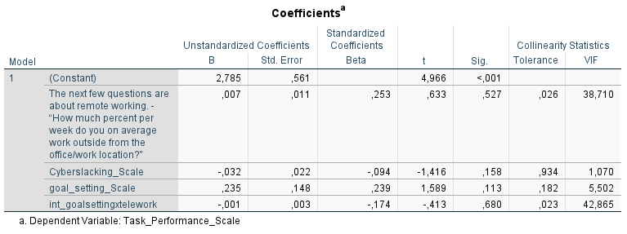

***Uncorrelatedness of residuals***



***Outliers***

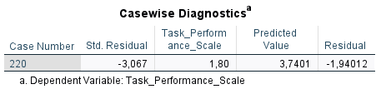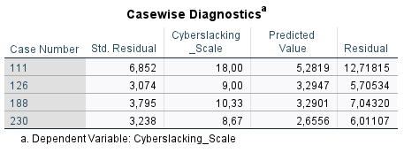

***Homoscedasticity***

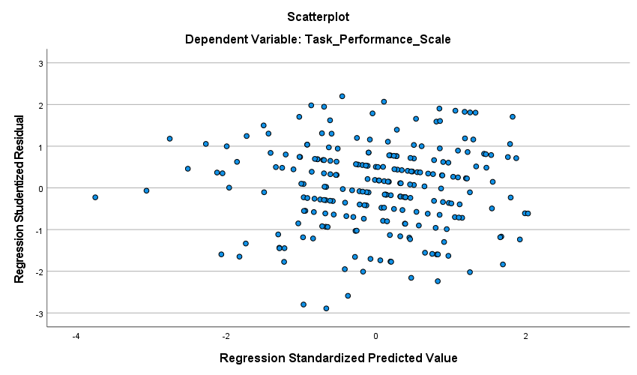

***Normality***

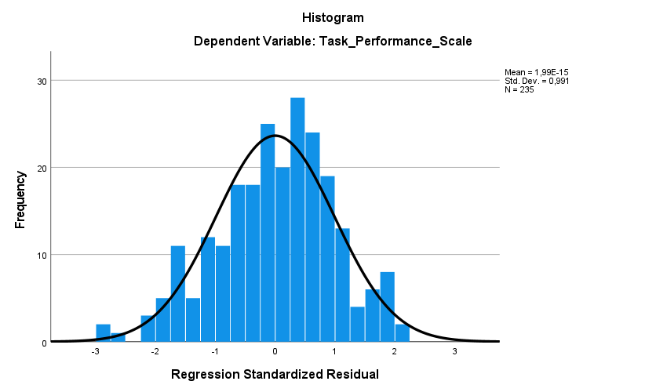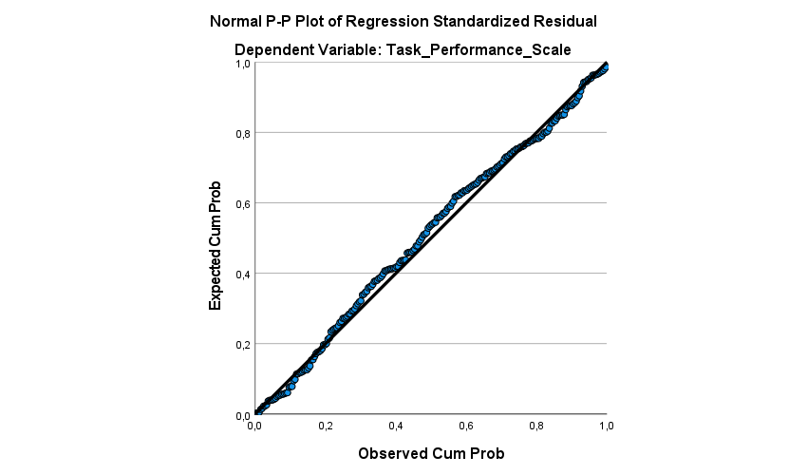

***Linearity***

